Simulating Gnutella Peer to Peer Self Organization Protocol

Manish M Kochhal
(April 29th 2003)

Introduction
There has been a significant and rapidly growing impact on the Internet traffic due to the high popularity of P2P applications. Therefore, there arises a necessity to study the performance and scalability of various existing P2P networks.
Currently, there are several different architectures for P2P networks:
- Centralized: Napster and other similar systems have a constantly updated directory hosted at central locations. Nodes in the P2P network issue queries to the central directory to find which other nodes hold the desired files. However, problems of legality and poor scalability along with having single points of failure have led to several other alternative approaches.
- Decentralized but Structured: These systems have no central directory server, and so are decentralized, but have a significant amount of structure. By “structure” we mean that the P2P network topology is tightly controlled and that the files are placed not at random nodes but at specified locations that will make subsequent queries easier to satisfy. In “loosely structured” systems, this placement of files is based on hints; the Freenet P2P network is an example of such a system. In “highly structured” systems both the P2P network topology and the placement of files is precisely determined; this tightly controlled structure enables the system to satisfy queries very efficiently. However, a highly structured design may not work with an extremely transient population of nodes, which seems to be a practical scenario in currently available practical P2P networks like KAZAA.
- Decentralized and Unstructured: These are systems in which there is neither a precise control over the network topology or file placement. Gnutella is an example of such designs. The network is formed by nodes joining the network following some loose rules. The resultant topology has certain properties, but the placement of files is not based on any knowledge of the topology (as it is in structured designs). To find a file, a node queries its neighbors. The most typical query method is flooding, where the query is propagated to all neighbors within a certain radius. These unstructured designs are extremely resilient to nodes entering and leaving the system.

Gnutella Protocol Specification (v 0.4) Outline

Protocol Definition: The Gnutella protocol defines the way in which peers communicate over the network. It consists of a set of descriptors used for communicating data between peers and a set of rules governing the inter-peer exchange of descriptors. In this paper, the following descriptors are defined:
  - Ping: Used to actively discover hosts on the network. A peer receiving a Ping descriptor is expected to respond with one or more Pong descriptors.
  - Pong: The response to a Ping. Includes the address of a connected Gnutella Peer and information regarding the amount of data it is making available to the network.
  - Query: The primary mechanism for searching the distributed network. A servent (i.e. a peer) receiving a Query descriptor will respond with a QueryHit if a match is found against its local data set.
  - QueryHit: The response to a Query. The descriptor provides the recipient with enough information to acquire the corresponding Query.
  - HeartBeat: The HeartBeat descriptor is send periodically by each peer to its neighbor peers in order to check their availability.

Simulation
We have developed a single process discrete event P2P simulator in Java (jdk 1.3). The simulation package is organized as follows:

p2psimulator:
- /util – package that includes utility classes like PriorityQueue, FormatWriter etc.
- /prng – package that include the pseudo random number generators and the various distribution like ExponentialRandom, ParetoRandom etc.
- /element – package that includes all the simulator elements that need to be updated during runtime. For example, a peer is modeled as a Node whose state has to be updated via update functions.
- /generators – package that includes the topology generator, traffic scenario generator, shared files scenario generators.
- /scen – files where generators write and readers read to the simulation scenarios respectively.
- /protocol – Gnutella Protocol specific code is implemented here. This includes a message package and a ProtocolAgent.
- /command – package that includes the command that is passed with its handler to the simulator event queue which is ordered according to time and it executes the Command.execute() function of any command that extends from class Command. Examples include SendMsgCommand, NodeStateCommand, StopCommand, etc.
- /test – package that has several Test classes to test the simulation package.

The following lists the files in each directory of the p2psimulator package:

/util
- BandwidthEventTypes.java
- CapacityEventTypes.java
- Dictionary.java
- DistributionInfo.java
- DistributionTypes.java
- FileTypes.java
- FormatWriter.java
- MD5.java
- Preferences.java
- PriorityQueue.java
- QueryTypes.java
- Queue.java
- SharedFileDatabase.java
- SharedFilesReader.java
- Status.java
- TopologyReader.java
- TrafficEventTypes.java
- TrafficScenarioReader.java

/prng
Distribution.java

/element
- Element.java
- FileShared.java
- Node.java
- Queue.java

/generators
- Coordinates.java
- GenerateSharedFilesScenario.java
- TopologyScenarioGenerator.java
- TrafficScenarioGenerator.java

/scen
  - audioFiles.txt
  - videoFiles.txt
  - documentFiles.txt
  - softwareFiles.txt
  - dictionary_words.txt
  - somefile.txt
  - topologyScenarioFile.txt
  - trafficScenarioFile.txt

/protocol
- ProtocolAgent.java
- /message
  - HeartBeatMessage.java
  - Message.java
  - MessageConstants.java
  - PingMessage.java
  - PongMessage.java
  - QueryHitMessage.java
  - QueryMessage.java

/command
    - Command.java
    - ElementUpdateCommand.java
    - InitializeCommand.java
    - NodeBandwidthCommand.java
    - NodeCapacityCommand.java
    - NodeStateCommand.java
    - QueryCommand.java
    - SendMessageCommand.java
    - StopCommand.java
    - TimeOutCommand.java
/test
- TestSharedFileDatabase.java
- TestSharedFileScenarioGenerator.java
- Test_Dictionary.java

And finally Simulator.java and Test_P2PSimulator.java

Protocol Finite State Diagram
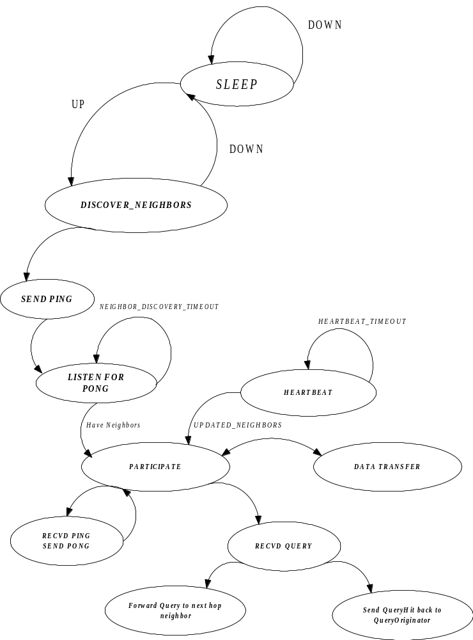

Test Run

- 10 Node Overlay Network Topology
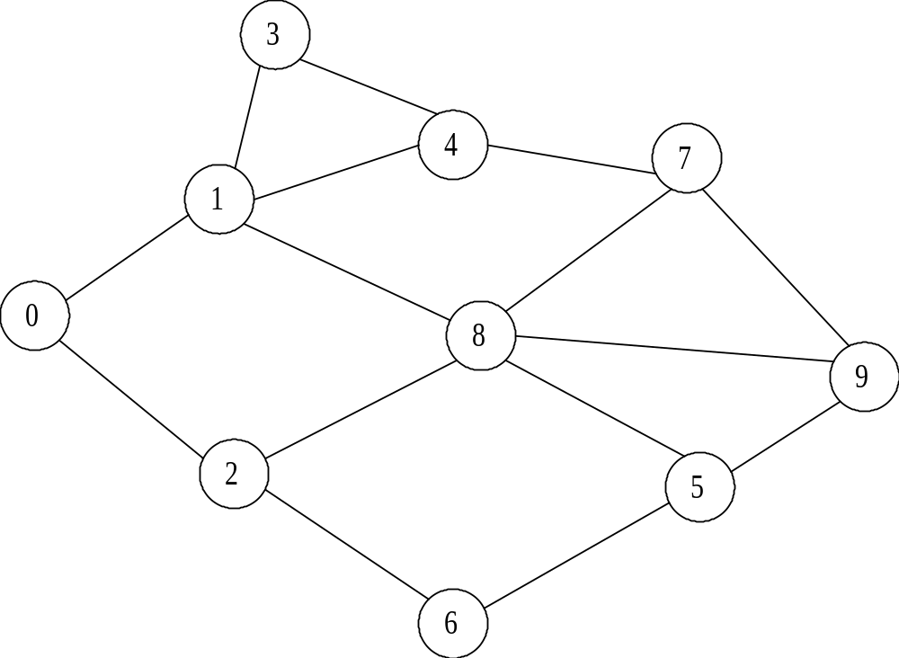

- topologyScenarioFile.txt

0: (20, 10) 2 {1, 2} {500 Mhz, 256 MB, 5000 MB, 100 Mbps};
1: (25, 60) 4 {0, 3, 4, 8} {1000 Mhz, 512 MB, 20000 MB, 10 Mbps};
2: (30, 1) 3 {0, 6, 8} {266 Mhz, 64 MB, 2000 MB, 10 Mbps};
3: (10, 78) 2 {1, 4} {900 Mhz, 128 MB, 10 MB, 0.056 Mbps};
4: (14, 9) 3 {1, 3, 7} {2000 Mhz, 256 MB, 20 MB, 1 Mbps};
5: (5, 10) 3 {6, 8, 9} {2000 Mhz, 256 MB, 20 MB, 10 Mbps};
6: (60, 54) 2 {2, 5} {900 Mhz, 128 MB, 10 MB, 1 Mbps};
7: (77, 7) 3 {4, 8, 9} {1700 Mhz, 512 MB, 40000 MB, 100 Mbps};
8: (88, 90) 5 {1, 2, 5, 7, 9} {5000 Mhz, 1000 MB, 100000 MB, 1000 Mbps};
9: (99, 90) 3 {5, 7, 8} {2530 Mhz, 1000 MB, 50000 MB, 100 Mbps};

- trafficScenarioFile.txt

0: 10 -INITIALIZE-;
0: 0 -UP-;
0: 1 -UP-;
0: 2 -UP-;
0: 3 -UP-;
0: 4 -UP-;
0: 5 -UP-;
0: 6 -UP-;
0: 7 -UP-;
0: 8 -UP-;
0: 9 -UP-;
600: 0 -INITIATE_PARTIAL_QUERY- 2 {Celine, Dion} .mp3 (4);
900: 2 -INITIATE_PARTIAL_QUERY- 1 {I} .mp3 (4);
10000: 10 -STOP_SIMULATION-;

- Simulation Output
Creating 10 Node Objects
0.0 seconds: Node 0 initializing !!!
0: (20, 10) 2 {1, 2} {500.0 Mhz, 256.0 MB, 5000.0 MB, 100.0 Mbps};
Node 0: Starting Gnutella agent ...
0.0 seconds: Node 1 initializing !!!
1: (25, 60) 4 {0, 3, 4, 8} {1000.0 Mhz, 512.0 MB, 20000.0 MB, 10.0 Mbps};
Node 1: Starting Gnutella agent ...
0.0 seconds: Node 2 initializing !!!
2: (30, 1) 3 {0, 6, 8} {266.0 Mhz, 64.0 MB, 2000.0 MB, 10.0 Mbps};
Node 2: Starting Gnutella agent ...
0.0 seconds: Node 3 initializing !!!
3: (10, 78) 2 {1, 4} {900.0 Mhz, 128.0 MB, 10.0 MB, 0.056 Mbps};
Node 3: Starting Gnutella agent ...
0.0 seconds: Node 4 initializing !!!
4: (14, 9) 3 {1, 3, 7} {2000.0 Mhz, 256.0 MB, 20.0 MB, 1.0 Mbps};
Node 4: Starting Gnutella agent ...
0.0 seconds: Node 5 initializing !!!
5: (5, 10) 3 {6, 8, 9} {2000.0 Mhz, 256.0 MB, 20.0 MB, 10.0 Mbps};
Node 5: Starting Gnutella agent ...
0.0 seconds: Node 6 initializing !!!
6: (60, 54) 2 {2, 5} {900.0 Mhz, 128.0 MB, 10.0 MB, 1.0 Mbps};
Node 6: Starting Gnutella agent ...
0.0 seconds: Node 7 initializing !!!
7: (77, 7) 3 {4, 8, 9} {1700.0 Mhz, 512.0 MB, 40000.0 MB, 100.0 Mbps};
Node 7: Starting Gnutella agent ...
0.0 seconds: Node 8 initializing !!!
8: (88, 90) 5 {1, 2, 5, 7, 9} {5000.0 Mhz, 1000.0 MB, 100000.0 MB, 1000.0 Mbps};
Node 8: Starting Gnutella agent ...
0.0 seconds: Node 9 initializing !!!
9: (99, 90) 3 {5, 7, 8} {2530.0 Mhz, 1000.0 MB, 50000.0 MB, 100.0 Mbps};
Node 9: Starting Gnutella agent ...
0.0: node 0 is UP
0.0: node 0 is sending PING to 1 with delay 1.54752
0.0: node 0 is sending PING to 2 with delay 0.300188
0.0: node 1 is UP
0.0: node 1 is sending PING to 0 with delay 1.51916
0.0: node 1 is sending PING to 3 with delay 0.296544
0.0: node 1 is sending PING to 4 with delay 1.628844
0.0: node 1 is sending PING to 8 with delay 1.902824
0.0: node 2 is UP
0.0: node 2 is sending PING to 0 with delay 0.286698
0.0: node 2 is sending PING to 6 with delay 1.96748
0.0: node 2 is sending PING to 8 with delay 1.80245
0.0: node 3 is UP
0.0: node 3 is sending PING to 1 with delay 0.57484
0.0: node 3 is sending PING to 4 with delay 2.14368
0.0: node 4 is UP
0.0: node 4 is sending PING to 1 with delay 1.420592
0.0: node 4 is sending PING to 3 with delay 2.63711
0.0: node 4 is sending PING to 7 with delay 1.507928
0.0: node 5 is UP
0.0: node 5 is sending PING to 6 with delay 1.195124
0.0: node 5 is sending PING to 8 with delay 4.524822
0.0: node 5 is sending PING to 9 with delay 4.449904
0.0: node 6 is UP
0.0: node 6 is sending PING to 2 with delay 1.76826
0.0: node 6 is sending PING to 5 with delay 2.36989
0.0: node 7 is UP
0.0: node 7 is sending PING to 4 with delay 1.250024
0.0: node 7 is sending PING to 8 with delay 2.35348
0.0: node 7 is sending PING to 9 with delay 0.8088
0.0: node 8 is UP
0.0: node 8 is sending PING to 1 with delay 1.83768
0.0: node 8 is sending PING to 2 with delay 3.46644
0.0: node 8 is sending PING to 5 with delay 1.255032
0.0: node 8 is sending PING to 7 with delay 2.474096
0.0: node 8 is sending PING to 9 with delay 0.211674
0.0: node 9 is UP
0.0: node 9 is sending PING to 5 with delay 2.669526
0.0: node 9 is sending PING to 7 with delay 3.357424
0.0: node 9 is sending PING to 8 with delay 0.435468
0.211674: node 9 received PING from 8
0.211674: node 9 is sending PONG to 8 with delay 0.322182
0.286698: node 0 received PING from 2
0.286698: node 0 is sending PONG to 2 with delay 0.414494
0.296544: node 3 received PING from 1
0.296544: node 3 is sending PONG to 1 with delay 0.590712
0.300188: node 2 received PING from 0

0.300188: node 2 is sending PONG to 0 with delay 0.467072
0.435468: node 8 received PING from 9
0.435468: node 8 is sending PONG to 9 with delay 0.154444
0.533856: node 8 received PONG from 9
0.57484: node 1 received PING from 3
0.57484: node 1 is sending PONG to 3 with delay 0.456104
0.589912: node 9 received PONG from 8
0.701192: node 2 received PONG from 0
0.76726: node 0 received PONG from 2
0.8088: node 9 received PING from 7
0.8088: node 9 is sending PONG to 7 with delay 1.82356
0.887256: node 1 received PONG from 3
1.030944: node 3 received PONG from 1
1.195124: node 6 received PING from 5
1.195124: node 6 is sending PONG to 5 with delay 0.904448
1.250024: node 4 received PING from 7
1.250024: node 4 is sending PONG to 7 with delay 1.40331
1.255032: node 5 received PING from 8
1.255032: node 5 is sending PONG to 8 with delay 2.272172
1.420592: node 1 received PING from 4
1.420592: node 1 is sending PONG to 4 with delay 1.333458
1.507928: node 7 received PING from 4
1.507928: node 7 is sending PONG to 4 with delay 1.744872
1.51916: node 0 received PING from 1
1.51916: node 0 is sending PONG to 1 with delay 1.146444
1.54752: node 1 received PING from 0
1.54752: node 1 is sending PONG to 0 with delay 0.574404
1.628844: node 4 received PING from 1
1.628844: node 4 is sending PONG to 1 with delay 1.865096
1.76826: node 2 received PING from 6
1.76826: node 2 is sending PONG to 6 with delay 1.67675
1.80245: node 8 received PING from 2
1.80245: node 8 is sending PONG to 2 with delay 1.673556
1.83768: node 1 received PING from 8
1.83768: node 1 is sending PONG to 8 with delay 1.05088
1.902824: node 8 received PING from 1
1.902824: node 8 is sending PONG to 1 with delay 2.18853
1.96748: node 6 received PING from 2
1.96748: node 6 is sending PONG to 2 with delay 1.9126
2.099572: node 5 received PONG from 6
2.121924: node 0 received PONG from 1
2.14368: node 4 received PING from 3
2.14368: node 4 is sending PONG to 3 with delay 2.932308
2.35348: node 8 received PING from 7
2.35348: node 8 is sending PONG to 7 with delay 1.998592
2.36989: node 5 received PING from 6
2.36989: node 5 is sending PONG to 6 with delay 1.90662
2.474096: node 7 received PING from 8
2.474096: node 7 is sending PONG to 8 with delay 2.054624
2.6323600000000003: node 7 received PONG from 9
2.63711: node 3 received PING from 4
2.63711: node 3 is sending PONG to 4 with delay 1.322936
2.653334: node 7 received PONG from 4
2.665604: node 1 received PONG from 0
2.669526: node 5 received PING from 9
2.669526: node 5 is sending PONG to 9 with delay 2.757816
2.7540500000000003: node 4 received PONG from 1
2.88856: node 8 received PONG from 1
3.2527999999999997: node 4 received PONG from 7
3.357424: node 7 received PING from 9
3.357424: node 7 is sending PONG to 9 with delay 2.002252
3.44501: node 6 received PONG from 2
3.46644: node 2 received PING from 8
3.46644: node 2 is sending PONG to 8 with delay 1.428854
3.476006: node 2 received PONG from 8
3.4939400000000003: node 1 received PONG from 4
3.527204: node 8 received PONG from 5
3.88008: node 2 received PONG from 6
3.9600459999999997: node 4 received PONG from 3
4.091354: node 1 received PONG from 8
4.27651: node 6 received PONG from 5
4.352072: node 7 received PONG from 8
4.449904: node 9 received PING from 5
4.449904: node 9 is sending PONG to 5 with delay 3.428068
4.524822: node 8 received PING from 5
4.524822: node 8 is sending PONG to 5 with delay 3.161988
4.52872: node 8 received PONG from 7
4.895294: node 8 received PONG from 2
5.075988: node 3 received PONG from 4
5.359676: node 9 received PONG from 7
5.4273419999999994: node 9 received PONG from 5
7.68681: node 5 received PONG from 8
7.877972: node 5 received PONG from 9
Node 0: at time 600.0 sending <PARTIAL_QUERY> to next hop neighbor 2
Node 0: at time 600.0 sending <PARTIAL_QUERY> to next hop neighbor 1
601.031885: node 2 received QUERY from 0
Node 2: at time 601.031885 found 8 matching files for node 0
602.342355: node 1 received QUERY from 0
Node 1: at time 602.342355 forwarding <PARTIAL_QUERY> for node 0 to next hop neighbor 3
Node 1: at time 602.342355 forwarding <PARTIAL_QUERY> for node 0 to next hop neighbor 4
Node 1: at time 602.342355 forwarding <PARTIAL_QUERY> for node 0 to next hop neighbor 8
603.355595: node 0 received QUERY_HIT from 2
603.495525: node 3 received QUERY from 1
Node 3: at time 603.495525 forwarding <PARTIAL_QUERY> for node 0 to next hop neighbor 4
604.321915: node 8 received QUERY from 3
Node 8: at time 604.321915 found 12 matching files for node 0 and forwarding it via node 3
604.75356: node 4 received QUERY from 3
Node 4: at time 604.75356 found 20 matching files for node 0 and forwarding it via node 3
608.951805: node 4 received QUERY from 3
Node 4: at time 608.951805 found 20 matching files for node 0 and forwarding it via node 3
610.582015: node 3 received QUERY_HIT from 8
612.72176: node 3 received QUERY_HIT from 4
614.093555: node 3 received QUERY_HIT from 4
Node 2: at time 900.0 sending <PARTIAL_QUERY> to next hop neighbor 0
Node 2: at time 900.0 sending <PARTIAL_QUERY> to next hop neighbor 8
Node 2: at time 900.0 sending <PARTIAL_QUERY> to next hop neighbor 6
900.88643: node 0 received QUERY from 2
Node 0: at time 900.88643 found 14 matching files for node 2
901.87512: node 6 received QUERY from 2
Node 6: at time 901.87512 found 11 matching files for node 2
903.0052400000001: node 2 received QUERY_HIT from 0
904.78863: node 8 received QUERY from 2
Node 8: at time 904.78863 found 6 matching files for node 2
906.35008: node 2 received QUERY_HIT from 6
910.48635: node 2 received QUERY_HIT from 8
Node 0: at time 2280.0 sending <HEARTBEAT> to 2

9486.78725: node 1 received HEART_BEAT from 8

9487.42176: node 5 received HEART_BEAT from 9
:
:
:
10000.0 seconds: Node 0 finishing !!!

10000.0 seconds: Node 1 finishing !!!
:
:
10000.0 seconds: Node 9 finishing !!!

Drawbacks:
We assumed an arbitrary random topology with arbitrary files shared and an arbitrary traffic pattern generation.

Conclusions:
Gnutella or other decentraliuzed P2P protocol can be studied and analyzed in great detail, but with some modifications to the simulator.

Future Work:
Using several distributions like Zipf and Pareto, we can extend the Generators to generate scenarios accordingly. Similarly Power Law models can be used to generate close Internet-like topology.

